Dremel Rotary Tool

**+** DON’T GO FOR CORDLESS VERSION  
**+** CHECK ITS RATED 220V  
**+** SAFETY GOGGLES

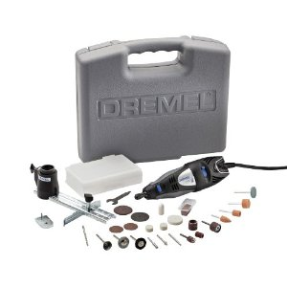

dremel 300 1/24

[**Sri Varu Power Tools Company 's Address**](http://bangalore.magicpages.in/sri-varu-power-tools-company-silver-jubilee-park-road-bangalore_contact-details.htm)  
22, S J P Raod  
Silver Jubilee Park Road  
Bangalore – 560002  
Phone: - 22224850, **Ph:** +91 9845665580  
Mr. Hari - 098450 50209  
**dremel 300/55 – 4690**

8884600788 (mr. Prasad)

GOODWILL ENTERPRISES  
#7/1, 1st floor  
subhan saheb lane  
sjp cross road, Bangalore  
tel no:080 41224344,41241804,22221255,22235456  
**carry only 4000 series, 200 & 300 discontinued  
4000-45 : 7.2K & 4000-65: 8K**

|  |
| --- |
| **KayVee Associates,** |
| No. 149, 37th Cross, 26th Main, 9th Block, |
| Jayanagar, Bangalore-10 |
|  |
| **Email:**[rajkayve@satyam.net.in](mailto:rajkayve@satyam.net.in) |
| **Ph:** +91 9880144909 |

**dremel 300+55 : 5.5K**

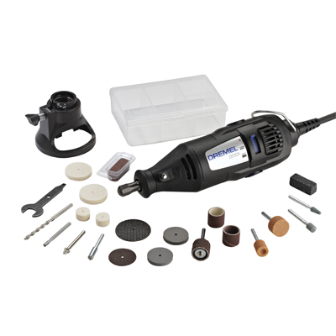

dremel 200 1/21 – two speed rotary toolkit  
<http://www.dremel.com/en-us/Tools/Pages/ToolDetail.aspx?pid=200-1%2f21&WT.ac=FET_200%20Series_200-1/21>

160Watts Chinese clone 'Mitsui' grinder with 33 attachments, flexi shaft and hanging stand. It cost me 1200 in Bangalore

Hypercity (@ Inorbit Madhapur), currently the 4000 is priced as Rs. 4600.00 (MRP 7000), 300 is for 1799.00\- **Not sure if its 55 accesory pack**

**dremel 300 1/24 :::**

**dremel 300 1/55 :::**

**dremel 200 1/21 :::**

